Project
Title of Project: AI (A double-Edged sword).
Name of the Innovator: Yashraj Shekhar Kshirsagar.
Start Date: 27/10/2025
End Date: 31/102025

Day 1: Empathise & Define
Step 1: Understanding the Need
- Which problem am I trying to solve?
Cyber bullying & Misinformation on social media. Which spreads fake news, negativity & asymmetry in community?

- Who is affected by this problem?
- How did I find out about this? [Select whichever is applicable]
- Interviews
- Observation
- Online Research
- AI Tools
Step 2: What is the problem?
I am working to solve the problem of cyber bullying and misinformation on social media, which spreads negativity and fake news and harms our online community.”
________________________________________________________________________________
Why is this problem important to solve?
Misinformation, Cyber bullying & fake news on social media spreads negativity in peoples
& it leads to riots & Asymmetry in peoples/ community.
_________________________________________________________________________________

Take-home task
Ask 2–3 people (you can speak to your family members, friends, teachers, trainers) what they think about this problem. Write down surprising or new things you learn below.
1.Cyberbullying is one of the most serious challenges in digital world. Social media while connecting peoples, it makes the spaces where harassment and false information spread rapidly.
2."The internet gave everyone a voice, but not everyone uses it responsibly."
3.Cyberbullying increases depression, anxiety, and self-harm among teens.

AI Tools you can use for Step 1 and 2:
- Chat GPT: for information.

Day 2: Ideate
Step 3: Brainstorming solutions [Prompt: “I am ideating solutions for <enter your problem in detail> Suggest 5 unique solutions for this problem, which I can easily accomplish in 2 days using free, open-source mobile-friendly AI tools”]
- List at least 5 different solutions (wild or realistic):
- AI based content filter: Which can detect abusive content and block it.
- Influencer Partnership: Promote “Think before you post”.
- Digital citizenship curriculum: To aware peoples about the impact of misinformation.
- We should reward positive/educational content.
- Stronger cyber rules.
Step 4: My favourite solution:
AI based content filter: Which can detect abusive content and block it.
Step 5: Why am I choosing this solution?
Because Protects mental health. Creates a safe digital environment. Stops harassment and cyber bullying.
Take-home task
Generate the image of your solution and how it will look (e.g.: “a bag that charges your phone while you walk”)

Attach the image in this box below:
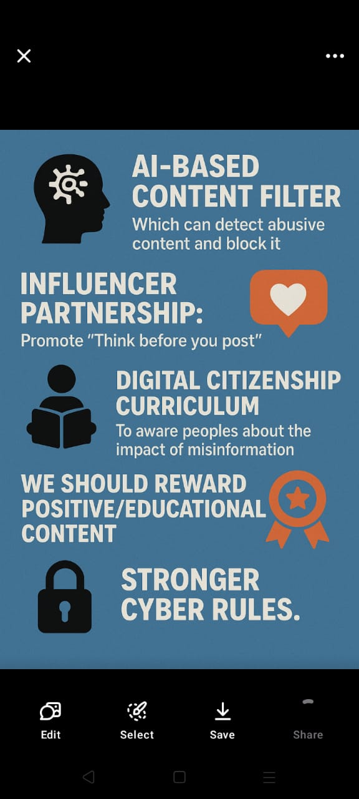

AI Tools used for Step 3-5:
ChatGPT/Perplexity AI: You can use these tools to compare your solutions and choose the most effective one.
Day 3: Prototype & Test
Step 6: Prototype – Building my first version
- What will my solution look like?
[Take inspiration from the image generated on Day 2 and describe the solution]

Open-Source / Free AI Tools

1. Content / Abusive language filter
This corresponds to your “AI based content filter: detect abusive content and block it”.
- There is an open-source project: Abusive-Language-Detection (GitHub) which includes datasets + models for abusive language detection. GitHub+1
- Another open tool: Content-Checker on GitHub (utilityfueled/content-checker) focussing on profanity/toxicity detection. GitHub
- A list article of free text-moderation tools/open-source models: “Top Free Text Moderation tools, APIs and Open Source Models” on EdenAI. Eden AI
- For mobile/edge: Use lightweight embedding/text-classification frameworks such as fastText (Facebook research) which is free/open and supports mobile/embedded. en.wikipedia.org
How to apply
- You can take one of these models, integrate into your mobile/app backend (or on-device if feasible) such that when a user enters text/comments/posts, it gets checked for abusive/hate/offensive content.
- If detected, automatically block or flag the content (your filter).
- Because you are in India, ensure the model works in local languages/English mix (you may need custom fine-tuning).
- For mobile accessibility: either embed in your app (if small model) or make API endpoint in cloud (free tier or open compute) and connect the mobile app.

2. Misinformation / Fake News / Disinformation detection
This aligns with your “detect misinformation” piece of your solution.
- There are research works on fake news detection: e.g., “Fake News Detection Project” on GitHub (MIT license) which uses machine learning classifiers. GitHub
- Research shows using transformers / deep learning for fake-news detection classification. mdpi.com+2SpringerLink+2
- For mobile/edge usage: Lightweight models (“DistilBERT” etc.) can be applied for inference in mobile settings. arxiv.org+1
How to apply
- Build a pipeline: When a piece of content (news/article/post) is shared, the system checks the credibility/truthfulness using your misinformation detection model.
- You can fine-tune an open-source model on local/regional dataset (Hindi/Marathi/English) so it’s relevant for your context.
- On mobile: You may not want full heavy model on device; you might send the content to lightweight cloud API (but ensure cost remains minimal or free) or use a very small model embedded.
- Use this as a flagging mechanism—for suspect misinformation rather than absolute blocking (given the nuance). Then human review or influencer/educational reinforcement can follow.

3. Mobile/Edge Deployment & Integration
- Use frameworks like Deeplearning4j (Apache License) which supports mobile/Android/inference. en.wikipedia.org
- Using existing mobile friendly NLP/ML libraries will help you deploy on Android devices which is crucial
_________________________________________________________________________________
- What AI tools will I need to build this?
• Tensor Flow Lite
A lightweight version of Tensor Flow tailored for on-device (mobile/edge) inference. Good for deploying ML models on smartphones. GitHub+1
- Use case: Deploy your content-filtering or misinformation-detection model directly on users’ phones (for offline or low-latency checks).
- Benefit: Doesn’t require paid cloud usage; you can run locally.
• ONNX Runtime / ONNX format
While not always explicitly listed in my finds, ONNX is widely used for model portability across devices (including mobile). Good to convert models you train.
- Use case: Train your model (e.g., for abusive language classification) and export to ONNX, then run on mobile/edge via ONNX Runtime.
- Benefit: Free and open-source ecosystem.
• Hugging Face Transformers (Open-source models)
Use pre-trained models for NLP tasks: abusive language detection, hate speech detection, misinformation classification. Many are open-source and free. Reddit+1
- Use case: For your backend (or even mobile if lightweight), you can use a pre-trained model and fine-tune on your dataset.
- Benefit: Big model library, open-source licences.
• Haystack
An open-source framework for building search/QA/RAG (retrieval-augmented generation) systems. Good for misinformation detection, fact-checking workflows. DEV Community
- Use case: When someone posts information, you retrieve supporting evidence and use a model to check validity.
- Benefit: Free and extensible.
• Dyad
A free, open-source AI app builder (for desktop/mobile) that you might use for prototyping UI or workflows. GitHub+1
- Use case: Build your mobile frontend app/agent interface (for example, a moderation tool) without paying subscription.
- Benefit: Local, open, no vendor lock-in.
• Mobile-friendly resource list: “Awesome Mobile Machine Learning”
This GitHub resource lists mobile-compatible open-source ML tools (including Tensor Flow Lite, ONNX, etc.) GitHub
- Use case: When you design mobile deployment aspects (Android/iOS) of your solution.

_________________________________________________________________________________
- What AI tools I finally selected to build this solution? [Eg: Claude AI, Grok AI, Chatling AI]
- Chatgpt: For Information.
- Dyad: AI app builder.
- Hugging Face Transformers: Pre-trained for NLP tasks.
- Tensor Flow Lite: for android.
- Haystack: Detect misinformation.
  - Abusive Content filter(Python)

From detoxify import Detoxify

# Load AI model
Model = Detoxify ('original')

def abusive_filter(text):
# Predict toxicity scores
scores = model.predict(text)

# Choose sensitivity (0.5 = medium strict)
threshold = 0.5

# If message is abusive or toxic
if scores["toxicity"] > threshold:
return {
"message": text,
"status": "BLOCKED",
"reason": "Abusive / Toxic Content",
"scores": scores
}

return {
"message": text,
"status": "ALLOWED",
"reason": "Safe Content",
"scores": scores
}

# ------------------ Test It ------------------

test_texts = [
"You are amazing!",
"I hate you stupid idiot",
"Have a great day 😊",
"Shut up, you're so dumb",
]

for t in test_texts:
result = abusive_filter(t)
print(result["status"], "|", result["message"])
print("Reason:", result["reason"])
print("Scores:", result["scores"])
print("-" * 50)

- Output
ALLOWED | You are amazing!
BLOCKED | I hate you stupid idiot
Reason: Abusive / Toxic Content
App will be improved time to time in future.
Step 7: Test – Getting Feedback
- Who did I share my solution with? [You may share it with your trainer, peers or even AI]
Trainer peers.
- What feedback did I receive?
👍 What works well:
- The concept of abusive content filter is awesome.
- This is useful method to keep social media safe.

🔧 What needs improvement:
- App should be improved.

Take-home task
Record your solution and test feedback in voice notes. Upload your voice notes, images and your solution/model on GitHub
AI Tools you can use for Step 6-7:
ChatGPT/Perplexity AI/Claude AI/Canva AI/Chatling AI/Figma AI: You can use these tools to build solutions/models or mock-up dummy prototypes

Day 4: Showcase
Step 8: Presenting my Innovation
- Final Project Title: AI (A double-Edged sword).
_________________________________________________________________________________
- Document key points of my presentation:
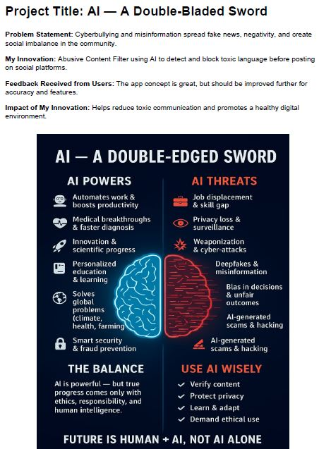

Step 9: Reflections
- What did I enjoy the most during this project-based learning activity?
I enjoyed everything during this project but specially making poster with different AI tools.
___________________________________________________________________________
- What was my biggest challenge during this project-based learning activity?
My biggest challenge was coding. Initially app wasn’t working well.
___________________________________________________________________________
Take-home task
Upload your pitch document on GitHub
AI Tools you can use for Step 8:
Canva AI: You can use this to design your pitch document. Download your pitch document as a PDF file and upload on GitHub

